AGENFORCE ADMINISTRATION WITH AGENTFORCE

Team ID : SWTID-2026-5389
Team Size : 5
Team Leader : Tamilselvan D
Team member : Theerthagiri M
Team member : Uthaya M
Team member : Thirumaran V
Team member : Tamilselvan A
Collage:Shanmuga Industries Arts & Science Collage,Tiruvannamalai.

Project Title: Courier Management System (CMS)

Courier Management System (CMS)

User Story:
Courier and logistics companies often struggle to efficiently manage shipments and deliveries due to reliance on manual processes and disconnected systems. The absence of a centralized shipment tracking mechanism makes it difficult to monitor parcel movement in real time, resulting in delayed delivery updates and poor visibility for customers. Delivery agent assignments are performed manually, increasing the chances of scheduling conflicts and operational delays. Furthermore, the lack of automated notifications prevents timely communication with customers, while the absence of performance analytics limits managerial insight into operational efficiency. Managing multiple branches becomes complex without an integrated platform, leading to coordination issues across locations. Collectively, these challenges result in customer dissatisfaction, reduced productivity, operational inefficiencies, and ultimately revenue loss for the organization.

1. INTRODUCTION

1.1 Project Overview :

Courier and logistics companies face challenges in efficiently managing shipments and deliveries due to manual operations and disconnected systems. These issues lead to delayed updates, poor customer visibility, and operational inefficiencies.
The Courier Management System (CMS) is a Salesforce-based cloud solution that centralizes shipment booking, tracking, delivery agent assignment, automated status updates, billing, and analytics. The system improves operational efficiency, enhances customer satisfaction, and provides real-time business insights.

1.2 Purpose :

The purpose of the Courier Management System (CMS) is to automate and centralize courier and logistics operations using the Salesforce platform. The system aims to replace manual and fragmented processes with an integrated digital solution that enables efficient shipment booking, real-time tracking, delivery agent assignment, automated notifications, billing, and performance reporting. By providing a single, unified platform for managing shipments across multiple branches, CMS improves operational visibility, enhances customer communication, reduces delays and errors, and supports faster decision-making through analytics. Ultimately, the system is designed to increase service efficiency, customer satisfaction, and overall business profitability.

2. IDEATION PHASE
2.1 Problem Statement (Customer Problem Statement Template)

PS | I am (Customer) | I’m trying to | But | Because | Which makes me feel
PS-1 | Branch Manager | manage shipments efficiently | tracking is manual | systems are disconnected | stressed
PS-2 | Customer | track parcels | updates are delayed | no centralized system | uncertain

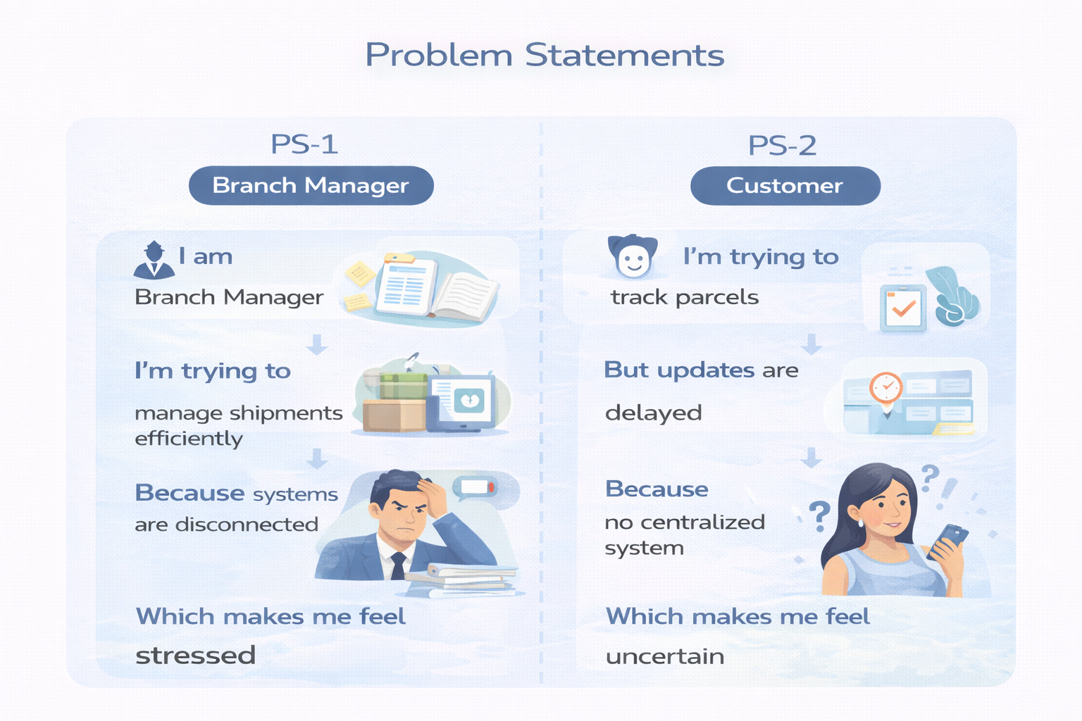

2.2 Empathy Map Canvas
User Persona: Branch Manager
- Think & Feel: Concerned about delays & errors
- Hear: Customer complaints
- See: Registers & spreadsheets
- Say & Do: Manual follow-ups
- Pain: Delivery conflicts & missed updates
- Gain: Automated tracking & dashboards
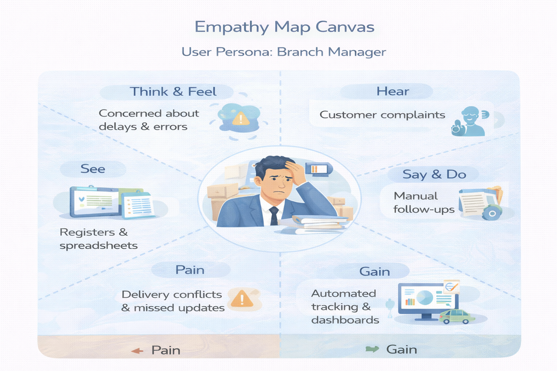

2.3 Brainstorming & Idea Prioritization
Ideas Considered
- Manual registers
- Spreadsheet tracking
- Standalone portal
- Salesforce CRM
Final Selection
Salesforce CRM selected due to:
- Automation
- Scalability
- Real-time visibility

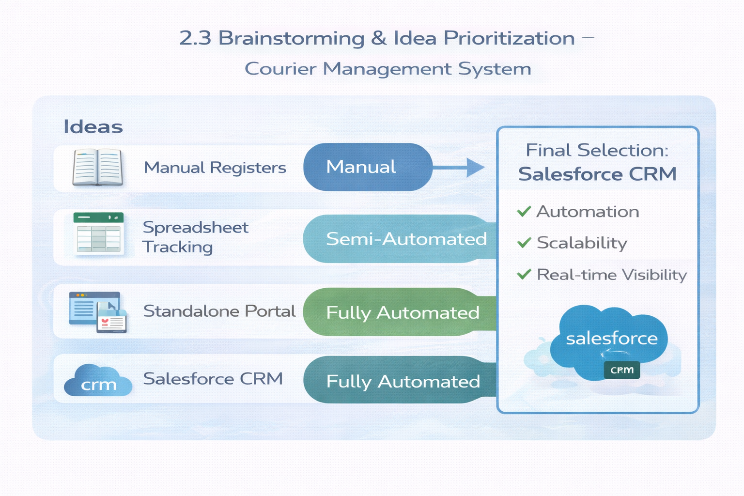

3.REQUIREMENT ANALYSIS PHASE

3.1 Customer Journey Map
Stages:
- Booking → Shipment Creation → Agent Assignment → Transit → Delivery Update → Invoice → Reporting

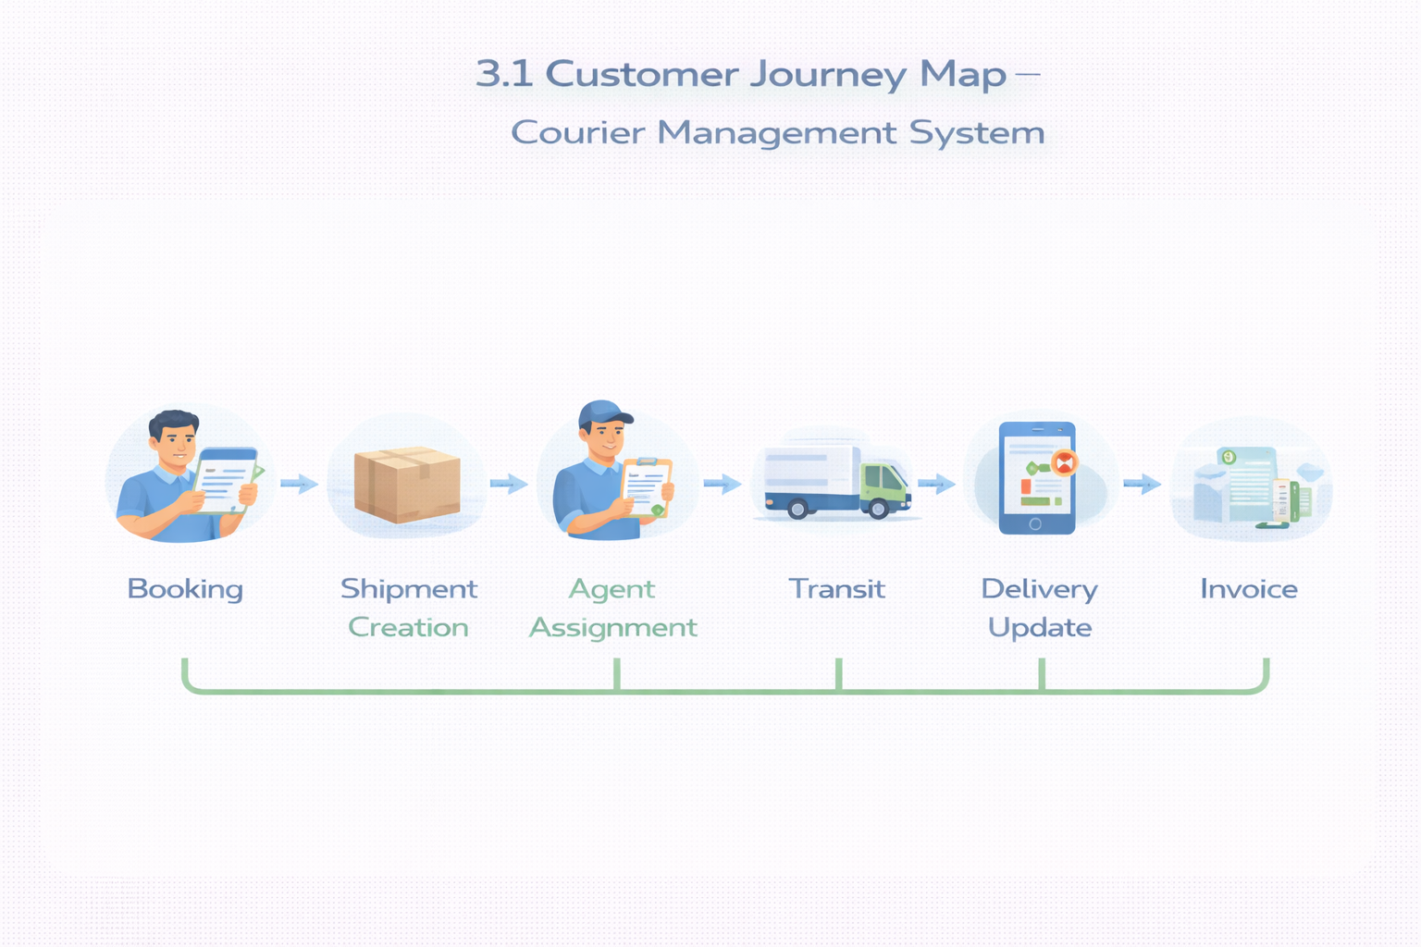

3.2 Solution Requirements
Functional Requirements

FR No | Requirement
FR-1 | Customer management
FR-2 | Shipment booking
FR-3 | Delivery agent assignment
FR-4 | Real-time status updates
FR-5 | Invoice generation
FR-6 | Reports & dashboards

Non-Functional Requirements

NFR | Description
Usability | Easy Lightning interface
Security | Role-based access control
Reliability | Error-free automation
Performance | Fast tracking updates
Availability | 24/7 cloud access
Scalability | Supports growing branches

3.3 Data Flow Diagram
Flow:
Customer Input → Shipment Creation → Validation → Agent Assignment → Delivery Update → Invoice → Reports
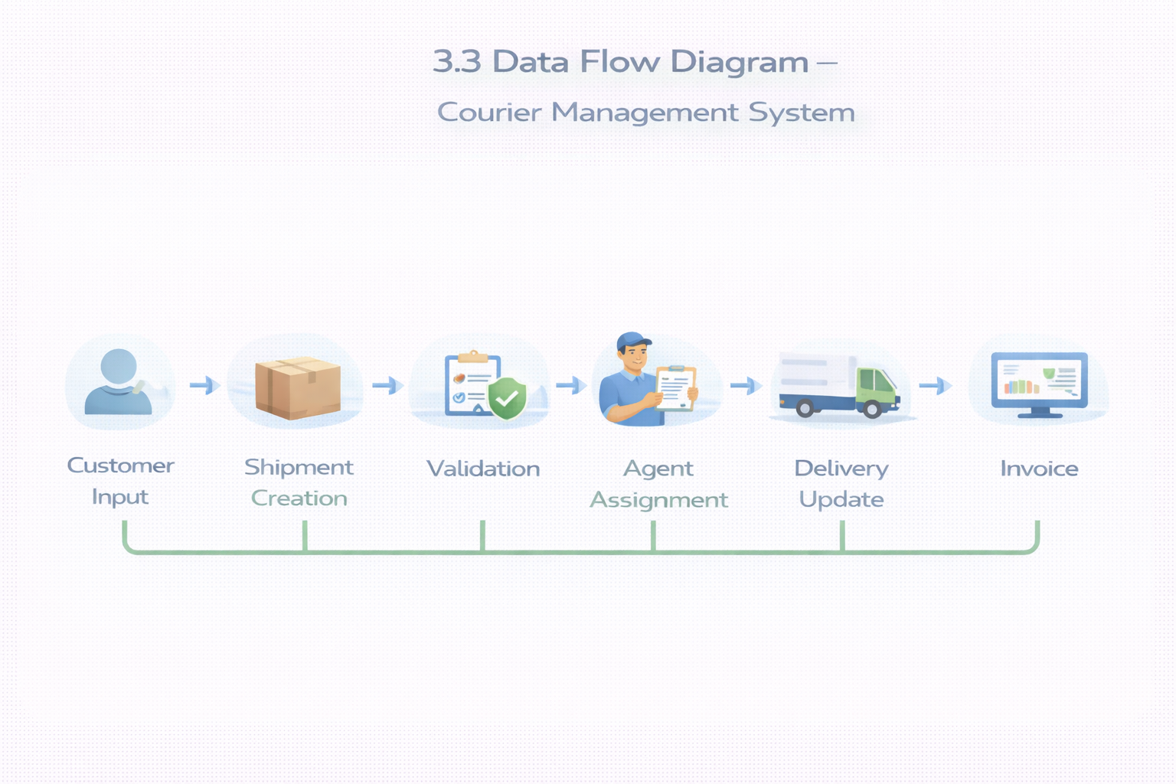

3.4 Technology Stack
Layer | Technology
UI | Salesforce Lightning
Logic | Salesforce Flows
Database | Salesforce Objects
Automation | Validation Rules, Flows
Security | Profiles, Roles
Reporting | Reports & Dashboards

4. PROJECT DESIGN PHASE

4.1 Problem–Solution Fit
CMS eliminates fragmented courier operations by automating shipment tracking, delivery assignment, billing, and reporting within a centralized Salesforce platform.
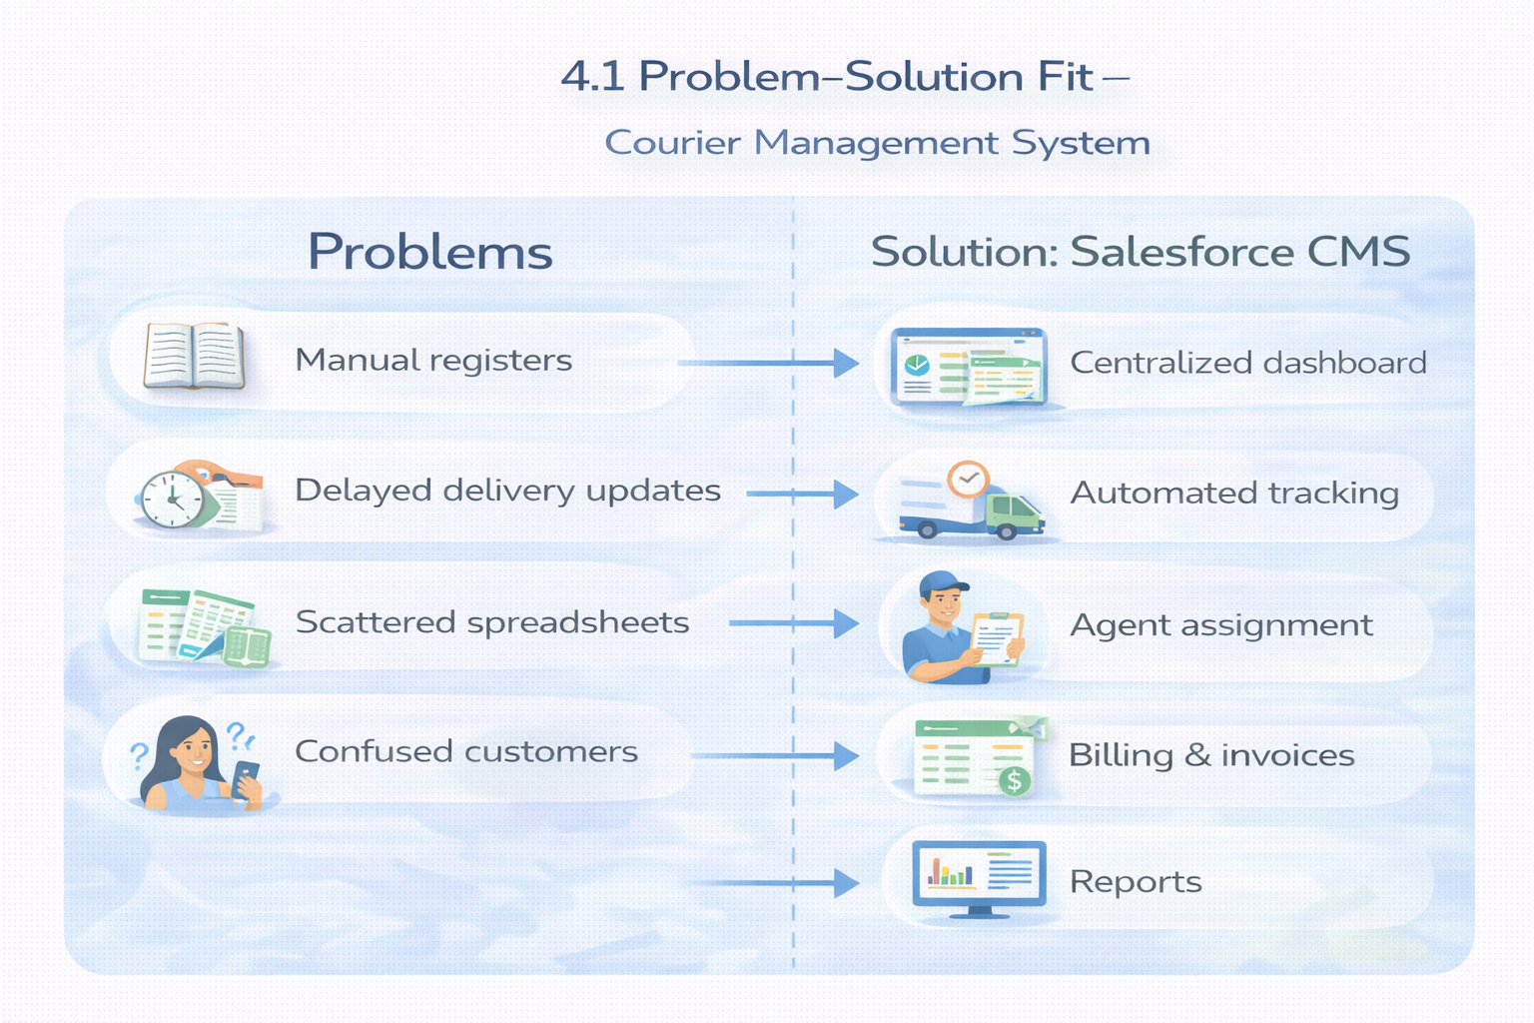

4.2 Proposed Solution
Functional Requirements

Parameter | Description
Problem | Manual shipment management
Solution | Salesforce CMS
Innovation | Automated tracking & billing
Impact | Faster deliveries
Business Model | Courier services
Scalability | Multi-branch ready

4.3 Solution Architecture
Components:
- Customer Object
- Shipment Object
- Delivery Agent Object
- Branch Object
- Delivery Update Object
- Invoice Object
- Flows
- Reports
- Dashboards

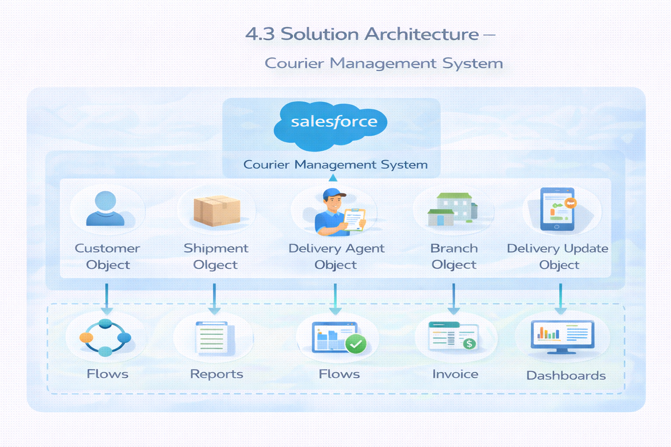

5. PROJECT PLANNING & SCHEDULING

5.1 Project Planning
- Agile methodology
- Epics → Stories → Story Points
- Sprint-based execution
- Velocity calculation used for estimation
Product Backlog, Sprint Schedule, and Estimation (4 Marks)
Use the below template to create product backlog and sprint schedule
Sprint | Functional Requirement (Epic) | User Story Number | User Story / Task | Story Points | Priority | Team Members
Sprint-1 | Developer Setup | USN-1 | As a system administrator, I want to create and configure a Salesforce developer account so that I can set up and deploy the Courier Management System. | 3 | High | Member1
Sprint-2 | Data Modeling | USN-2 | As an admin, I want to create Customer, Shipment, Delivery Agent, Branch, and Invoice objects with proper relationships so that courier data is stored and managed efficiently. | 5 | High | Member2
Sprint-2 | Data Modeling | USN-3 | As a staff member, I want tabs and a Lightning App for all courier modules so that I can easily navigate and perform daily operations. | 5 | High | Member3
Sprint-3 | Automation | USN-4 | As a system, I want to validate shipment details such as delivery dates, addresses, and mandatory fields so that incorrect or incomplete records are prevented. | 3 | High | Member4
Sprint-3 | Automation | USN-5 | As a dispatcher, I want automated flows for shipment status updates and agent assignment so that deliveries are processed faster without manual intervention. | 3 | High | Member4
Sprint-4 | Security | USN-6 | As an administrator, I want role-based access control for managers, agents, and staff so that sensitive shipment and billing data is secure. | 5 | High | Member2
Sprint-5 | Reports | USN-7 | As a branch manager, I want reports showing delivery performance, shipment status, and revenue so that I can monitor operations and make informed decisions. | 4 | High | Member3
Sprint-6 | Dashboards | USN-8 | As a branch manager, I want dashboards showing delivery performance, shipment status, and revenue so that I can monitor operations and make informed decisions. | 4 | Medium | Member4

Project Tracker, Velocity & Burndown Chart: (4 Marks)
Sprint | Total Story Points | Duration | Sprint Start Date | Sprint End Date (Planned) | Story Points Completed (as on Planned End Date) | Sprint Release Date (Actual)
Sprint-1 | 20 | 6 Days | 24 Oct 2022 | 29 Oct 2022 | 20 | 29 Oct 2022
Sprint-2 | 20 | 6 Days | 31 Oct 2022 | 05 Nov 2022
Sprint-3 | 20 | 6 Days | 07 Nov 2022 | 12 Nov 2022
Sprint-4 | 20 | 6 Days | 14 Nov 2022 | 19 Nov 2022

6. Project Development Phase:

What you'll learn
- Real-time Salesforce project implementation
- Designing custom objects and relationships
- Creating page layouts & record types
- Writing validation rules
- Building automation with flows
- Developing reports & dashboards
- Setting up security with profiles, permission sets, and sharing
- End-to-end application testing

Milestone 1: Salesforce Account
Introduction:
New to Salesforce and unsure where to start? Curious how real business applications—like loan processing and payment tracking—can be built on the platform? You’re in the right place.
Welcome to the Loan Management System project!
Salesforce offers powerful tools that help automate processes, improve accuracy, and manage customer operations with ease. In this project, you’ll learn how Salesforce can streamline lending workflows—from borrower onboarding to loan approval, EMI tracking, and document verification.
What Is Salesforce ?

Salesforce is your customer success platform, designed to help you sell, service, market, analyze, and connect with your customers. Salesforce has everything you need to run your business from anywhere. Using standard products and features, you can manage relationships with prospects and customers, collaborate and engage with employees and partners, and store your data securely in the cloud.

Activity 1: Creating Developer Account
Creating a developer org in salesforce.
- Go to https://developer.salesforce.com/signup
- On the sign up form, enter the following details :
3. First name & Last name
4. Email

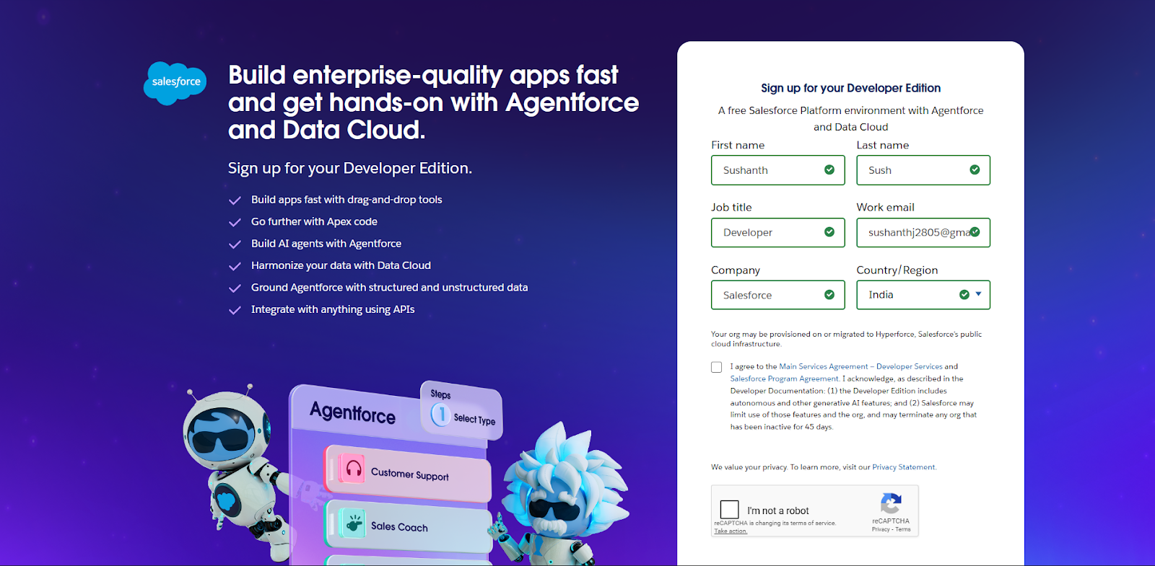

1) First name & Last name
2) Email
3) Job Title: Developer
4) Company: College Name
5) Country: India

Click on sign me up after filling these.

Activity 2: Account Activation
1. Go to the inbox of the email that you used while signing up. Click on the verify account to activate your account. The email may take 10-30 mins and sometimes 2 hours.


2. Click on Verify Account
3.Give a password and answer a security question and click on change password.
4.Then you will redirect to your salesforce setup page.


Milestone 2- Object:
What is an object?
Salesforce objects are database tables that permit you to store data that is specific to an
organization. It consists of fields (columns) and records (rows).
Custom Objects Created:
1. Customer__c – stores customer personal and contact information
2. Shipment__c – manages parcel details, source, destination, and tracking information
3. Delivery_Agent__c – maintains delivery agent profiles and branch details
4. Branch__c – represents courier branch offices
5. Delivery_Update__c – stores status updates for each shipment
6. Invoice__c – manages billing details for delivered shipments
Relationships:
Customer → Shipment (Lookup)
Shipment → Delivery_Agent (Lookup)
Delivery_Agent → Branch (Lookup)
Delivery_Update → Shipment (Master-Detail)
Invoice → Shipment (Lookup)

Steps to Implement :

Activity 1: Create Customer Object
- Click Setup → Object Manager → Create → Custom Object
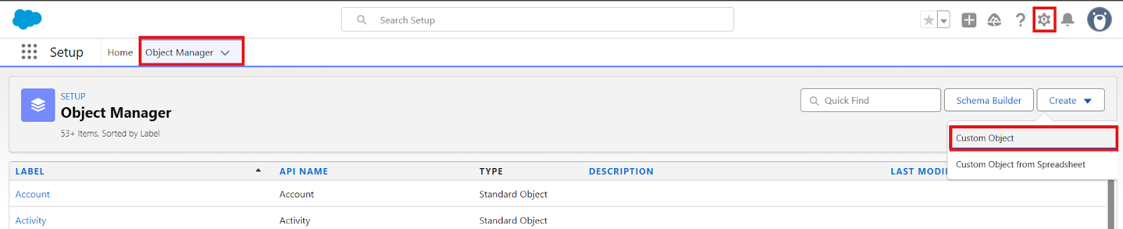
- Enter the following details:
- Label: Customer
- Plural Label: Customers
- Record Name: Customer Name (Text)
- Under Optional Features:
- Enable Allow Reports
- Enable Track Field History
- In Search Status check the box Allow Search
- In Object Creation Options check the box Add Notes and Attachments related list to default page layout
- Click Save.
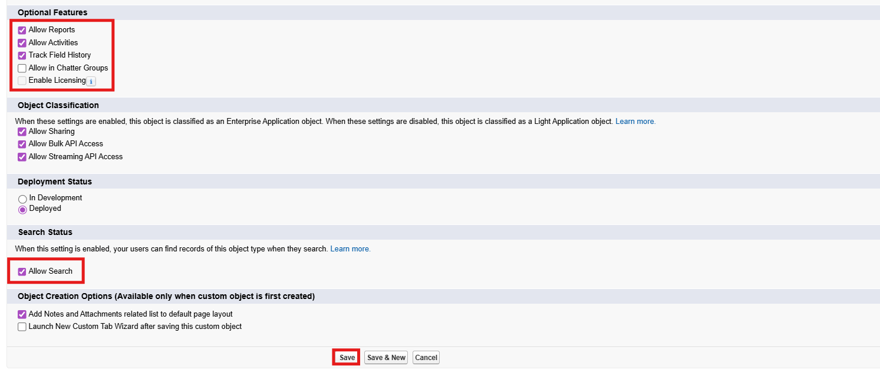

Activity 2: Create Shipment Object
- Go to Setup → Object Manager → Create → Custom Object
- Enter:
- Label: Shipment
- Plural Label: Shipments
- Record Name: Tracking Number (Auto Number)
- Example Format: SHP-{00000}
Starting Number: 0
- Enable:
- Allow Reports
- Track Field History
- Click Save

Activity 3: Create Delivery_Agent Object
- Setup → Object Manager → Create → Custom Object
- Enter:
- Label: Delivery Agent
- Plural Label: Delivery Agents
- Record Name: Agent Name (Text)
- Enable:
- Allow Reports
- Track Field History
- Click Save

Activity 4: Create Branch Object
- Setup → Object Manager → Create → Custom Object
- Enter:
- Label: Branch
- Plural Label: Branches
- Record Name: Branch Name (Text)
- Enable:
- Allow Reports
- Click Save.

Activity 5: Create Delivery_Update Object
- Setup → Object Manager → Create → Custom Object
- Enter:
- Label: Delivery Update
- Plural Label: Delivery Updates
- Record Name: Update Number (Auto Number)
- Example Format: UPD-{0000}
Enter Starting number : 0
- Enable:
- Allow Reports
- Track Field History
- Click Save.

Activity 6: Create Invoice Object
- Setup → Object Manager → Create → Custom Object
- Enter:
- Label: Invoice
- Plural Label: Invoices
- Record Name: Invoice Number (Auto Number)
- Example Format: INV-{0000}
Enter Starting number: 0
- Enable:
- Allow Reports
- Track Field History
- Click Save
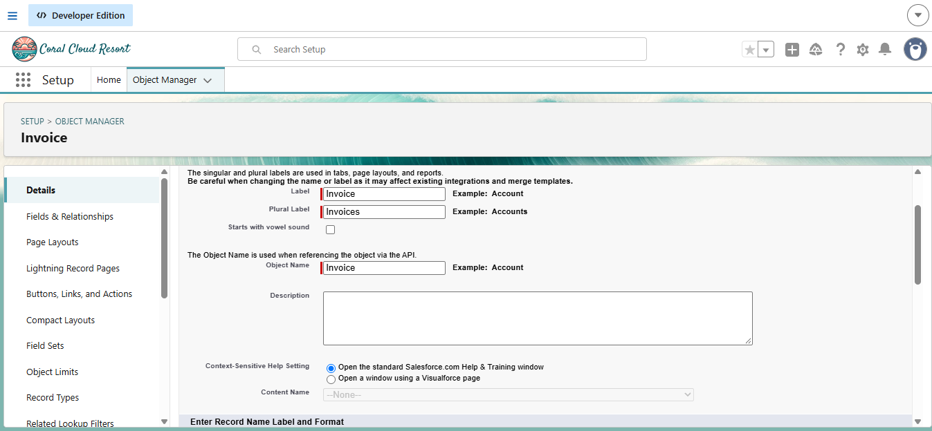

Milestone 3 - Tabs
Tab:
Tabs in Salesforce help users view the information at a glance. It displays the data of objects and other web content in the application.

Activity 1: Creating a Tab for Customer Object
- Click Home, type Tabs in Quick Find, and select Tabs.
- Under Custom Object Tabs, click New.
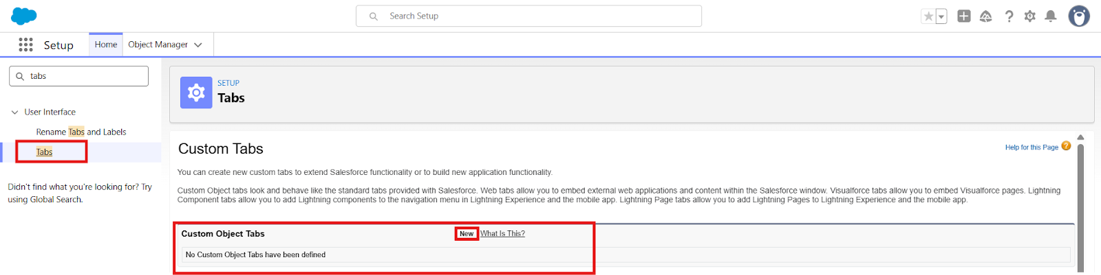
- For Object, select Customer.
- For Tab Style, choose any icon.
- Leave all default settings as they are.
- Click Next, Next, and Save.

Activity 2: Creating a Tab for Shipment Object
- Click Home, type Tabs in Quick Find, and select Tabs.
- Under Custom Object Tabs, click New.
- For Object, select Shipment.
- Choose any Tab Style.
- Keep defaults unchanged.
- Click Next, Next, and Save.

Activity 3: Creating a Tab for Delivery Agent Object
- Click Home, type Tabs in Quick Find, and select Tabs.
- Under Custom Object Tabs, click New.
- For Object, select Delivery Agent.
- Pick any Tab Style.
- Leave default settings.
- Click Next, Next, and Save.

Activity 4: Creating a Tab for Branch Object
- Click Home, type Tabs in Quick Find, and select Tabs.
- Under Custom Object Tabs, click New.
- For Object, select Branch.
- Choose any Tab Style.
- Keep all defaults.
- Click Next, Next, and Save.

Activity 5: Creating a Tab for Delivery Update Object
- Click Home, type Tabs in Quick Find, and select Tabs.
- Under Custom Object Tabs, click New.
- For Object, select Delivery Update.
- Select any Tab Style.
- Keep default configurations.
- Click Next, Next, and Save.

Activity 6: Creating a Tab for Invoice Object
- Click Home, type Tabs in Quick Find, and select Tabs.
- Under Custom Object Tabs, click New.
- For Object, select Invoice.
- Select any Tab Style.
- Leave defaults unchanged.
- Click Next, Next, and Save.
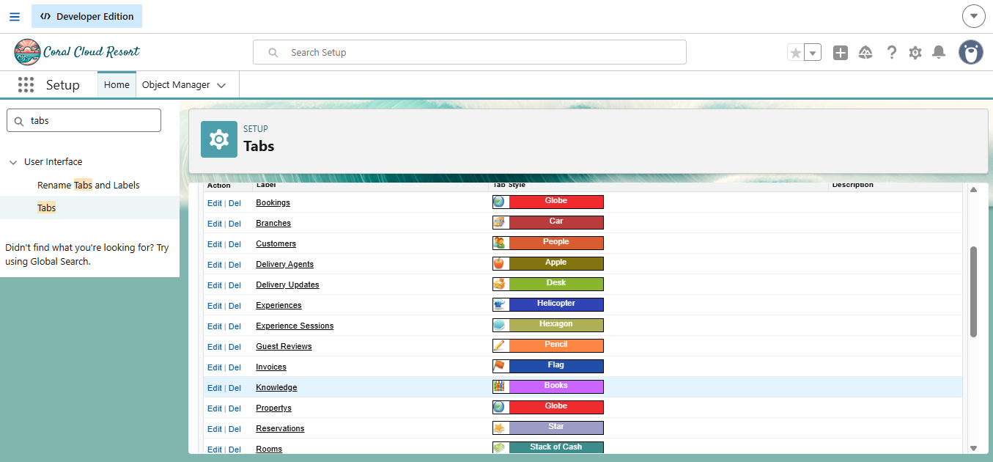

Milestone 4: Fields & Relationships
What are fields ?
Fields in Salesforce represent what the columns represent in relational databases. It can store
data values which are required for a particular object in a record.

Activity 1: Creation of fields for the Customer Object

Field Name | API Name | Data Type | Required | Description
Customer Name | Name | Text | Yes | Full name of customer
Email | Email__c | Email | Yes | Customer email
Phone | Phone__c | Phone | Yes | Customer contact number
Address | Address__c | Text Area | Yes | Customer address
Customer Type | Customer_Type__c | Picklist | Yes | Regular / Business
City | City__c | Text | No | Customer city
State | State__c | Text | No | Customer state
Pincode | Pincode__c | Text | No | Postal code
Is Active | Is_Active__c | Checkbox | No | Active status
1. Email (Email Field)
- Go to Setup → Object Manager → Customer__c
- Click Fields & Relationships → New
- Select Email → Next
- Field Label: Email
- Check the Required box
- Click Next → Next → Save
2. Phone (Phone Field)
- Setup → Object Manager → Customer__c
- Fields & Relationships → New
- Select Phone → Next
- Field Label: Phone
- Check Required
- Click Next → Next → Save
3. Address (Text Area)
- Setup → Object Manager → Customer__c
- Fields & Relationships → New
- Select Textarea → Next
- Field Label: Address
- Check Required
- Save
4. Customer Type (Picklist)
- Setup → Customer__c → Fields → New
- Picklist → Next
- Field Label: Customer Type
- Enter values:
  - Regular
  - Business
- Check Required
- Save
5. City (Text)
- Setup → Customer__c → Fields → New
- Text → Next
- Field Label: City
- Save
6. State (Text)
- Setup → Customer__c → Fields → New
- Text → Next
- Field Label: State
- Save
7. Pincode (Text)
- Setup → Customer__c → Fields → New
- Text → Next
- Field Label: Pincode
- Save
8. Is Active (Checkbox)
- Setup → Customer__c → Fields → New
- Checkbox → Next
- Field Label: Is Active
- Save

Activity 2: Creation of fields for the Shipment Object
Field Name | API Name | Data Type | Required | Description
Tracking Number | Name | Auto Number | Yes | Unique ID
Customer | Customer__c | Lookup(Customer) | Yes | Related customer
Source Address | Source_Address__c | Text Area | Yes | Pickup location
Destination Address | Destination_Address__c | Text Area | Yes | Delivery location
Weight | Weight__c | Number | Yes | Parcel weight
Price | Price__c | Currency | Yes | Shipping charge
Status | Status__c | Picklist | Yes | Shipment status
Expected Date | Expected_Date__c | Date | Yes | Delivery estimate
Assigned Agent | Assigned_Agent__c | Lookup(Delivery_Agent) | No | Delivery agent
Shipment Type | Shipment_Type__c | Picklist | Yes | Domestic/International

1. Source Address (Text Area)
- Setup → Shipment__c → Fields → New
- Textarea → Next
- Field Label: Source Address
- Required → Save
2. Destination Address (Text Area)
- Setup → Shipment__c → Fields → New
- Textarea → Next
- Field Label: Destination Address
- Required → Save
3. Weight (Number)
- Setup → Shipment__c → Fields → New
- Number → Next
- Field Label: Weight
- Required → Save
4. Price (Currency)
- Setup → Shipment__c → Fields → New
- Currency → Next
- Field Label: Price
- Required → Save

5. Status (Picklist)
Values:
- Booked
- In Transit
- Out for Delivery
- Delivered
- Cancelled
Required → Save
6. Expected Date (Date)
- Setup → Shipment__c → Fields → New
- Date → Next
- Field Label: Expected Date
- Required → Save
7. Shipment Type (Picklist)
Values:
- Domestic
- International
Required → Save

Activity 3: Creation of fields for Delivery_Agent Object

Field Name | API Name | Data Type | Required
Agent Name | Name | Text | Yes
Email | Email__c | Email | Yes
Phone | Phone__c | Phone | Yes
Branch | Branch__c | Lookup | Yes
Status | Status__c | Picklist | Yes
Joining Date | Joining_Date__c | Date | No

1. Email
- Setup → Delivery_Agent__c → Fields → New
- Email → Next
- Field Label: Email
- Required → Save
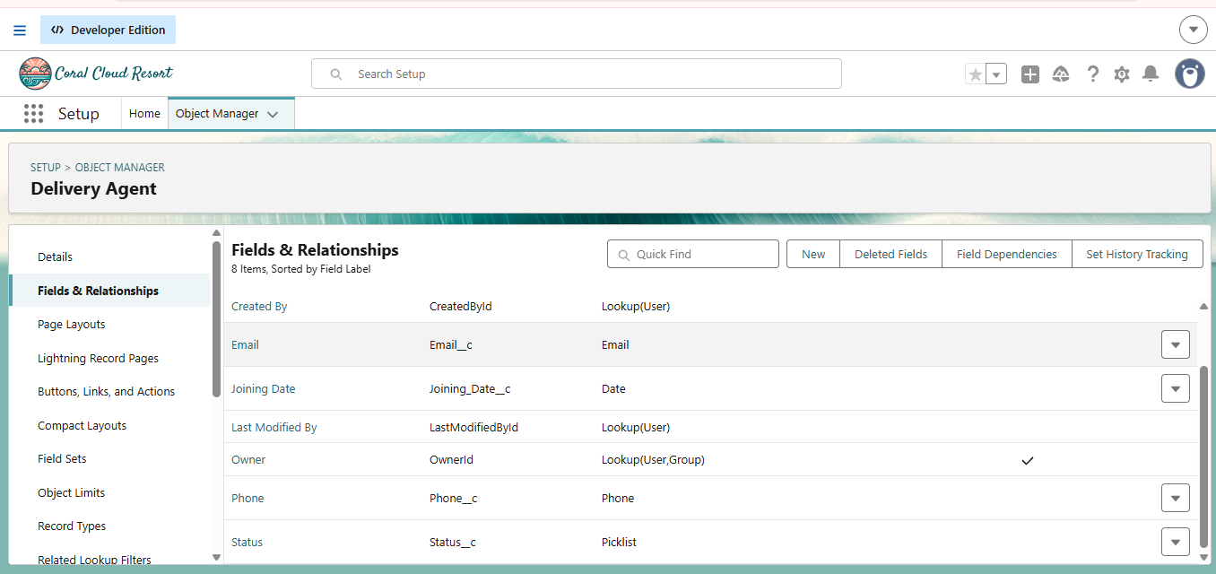
2. Phone
- Setup → Delivery_Agent__c → Fields → New
- Phone → Next
- Field Label: Phone
- Required → Save

3. Status (Picklist)
Values:
- Active
- Inactive
- On Leave
Required → Save
4. Joining Date
- Setup → Delivery_Agent__c → Fields → New
- Date → Next
- Field Label: Joining Date
- Save

Activity 4: Creation of fields for Branch Object

Field Name | API Name | Data Type | Required
Branch Name | Name | Text | Yes
Branch Code | Branch_Code__c | Text | Yes
City | City__c | Text | Yes
State | State__c | Text | Yes
Manager Name | Manager_Name__c | Text | No

Create each field using:
- Setup → Branch__c → Fields → New
- Select respective Data Type
- Enter Field Label
- Save
(Repeat for all fields)
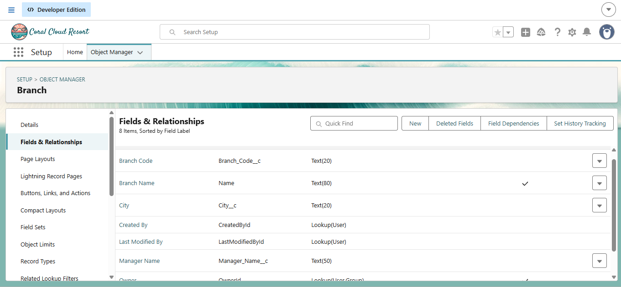

Activity 5: Creation of fields for Delivery_Update Object

Field Name | API Name | Data Type | Required
Update Number | Name | Auto Number | Yes
Shipment | Shipment__c | Master-Detail | Yes
Status | Status__c | Picklist | Yes
Update Date | Update_Date__c | DateTime | Yes
Remarks | Remarks__c | Text | No

Status Picklist Values:
- In Transit
- Out for Delivery
- Delivered
- Delayed
Required → Save

Activity 6: Creation of fields for Invoice Object

Field Name | API Name | Data Type | Required
Invoice Number | Name | Auto Number | Yes
Shipment | Shipment__c | Lookup | Yes
Amount | Amount__c | Currency | Yes
Invoice Date | Invoice_Date__c | Date | Yes
Payment Status | Payment_Status__c | Picklist | Yes

Payment Status Values
- Paid
- Unpaid
- Pending
Required → Save

Relationships :

Child Object | Field | Parent Object | Type
Shipment | Customer__c | Customer | Lookup
Shipment | Assigned_Agent__c | Delivery_Agent | Lookup
Delivery_Agent | Branch__c | Branch | Lookup
Delivery_Update | Shipment__c | Shipment | Master-Detail
Invoice | Shipment__c | Shipment | Lookup

Relationship Creation Steps :

Activity 1 – Shipment → Customer
- Setup → Shipment__c → Fields → New
- Lookup Relationship
- Related Object: Customer__c
- Field Label: Customer
- Save

Activity 2 – Shipment → Delivery Agent
- Setup → Shipment__c
- New → Lookup
- Object: Delivery_Agent__c
- Label: Assigned Agent
- Save

Activity 3 – Delivery Agent → Branch
- Setup → Delivery_Agent__c
- New → Lookup
- Related Object: Branch__c
- Label: Branch
- Save

Activity 4 – Delivery Update → Shipment
- Setup → Delivery_Update__c
- New → Master-Detail
- Related Object: Shipment__c
- Save

Activity 5 – Invoice → Shipment
- Setup → Invoice__c
- New → Lookup
- Object: Shipment__c
- Save

Milestone 5-Validation Rules :
Validation rules are applied when a user tries to save a record and are used to check if the data meets specified criteria. If the criteria are not met, the validation rule triggers an error message and prevents the user from saving the record until the issues are resolved.

Activity 1: Create Validation Rules on Customer__c
1. Validation Rule: Email Must Not Be Blank
Steps:
- Click the Gear icon → Setup
- Go to Object Manager
- Search and select Customer__c
- From the left menu, click Validation Rules
- Click New
- Rule Name: Email_Required
- Check Active
In Error Condition Formula, paste:
ISBLANK(Email__c)

- Click Check Syntax
- Error Message: Email is required.
- Error Location: Field → Email
- Click Save.
2. Validation Rule: Phone Must Be 10 Digits
Steps:
- Setup → Object Manager → Customer__c
- Validation Rules → New
- Rule Name: Validate_Phone_Number
- Check Active
Formula:
LEN(Phone__c) <> 10

- Check Syntax
- Error Message: Phone number must be 10 digits.
- Error Location: Field → Phone
- Save
3. Validation Rule: Pincode Must Be 6 Digits
Steps:
- Setup → Object Manager → Customer__c
- Validation Rules → New
- Rule Name: Validate_Pincode
- Active → Yes
Formula:
LEN(Pincode__c) <> 6

- Error Message: Pincode must be 6 digits.
- Location: Field → Pincode
- Save

Activity 2: Create Validation Rules on Shipment__c
1. Validation Rule: Weight Must Be Greater Than Zero
Steps:
- Setup → Object Manager → Shipment__c
- Click Validation Rules → New
- Rule Name: Validate_Weight
- Active → Checked
Formula:
Weight__c <= 0

- Check Syntax
- Error Message: Weight must be greater than zero.
- Location: Field → Weight
- Save
2. Validation Rule: Price Must Be Greater Than Zero
Steps:
- Setup → Object Manager → Shipment__c
- Validation Rules → New
- Rule Name: Validate_Price
- Active → Yes
Formula:
Price__c <= 0

- Error Message: Price must be greater than zero.
- Location: Field → Price
- Save
3. Validation Rule: Expected Date Cannot Be in the Past
Steps:
- Setup → Object Manager → Shipment__c
- Validation Rules → New
- Rule Name: Validate_Expected_Date
Formula:
Expected_Date__c < TODAY()

- Check Syntax
- Error: Expected delivery date cannot be in the past.
- Location: Field → Expected Date
- Save

Activity 3: Create Validation Rules on Delivery_Agent__c
1. Validation Rule: Email Must Be Valid
Steps:
- Setup → Object Manager → Delivery_Agent__c
- Validation Rules → New
- Rule Name: Validate_Agent_Email
- Active → Yes
Formula:
NOT(CONTAINS(Email__c, "@"))

- Error Message: Enter a valid email address.
- Location: Field → Email
- Save

Activity 4: Create Validation Rules on Branch__c
1. Validation Rule: Branch Code Must Not Be Blank
Steps:
- Setup → Object Manager → Branch__c
- Validation Rules → New
- Rule Name: Branch_Code_Required
Formula:
ISBLANK(Branch_Code__c)

- Error Message: Branch Code is mandatory.
- Location: Field → Branch Code
- Save

Activity 5: Create Validation Rules on Delivery_Update__c
1. Validation Rule: Remarks Required If Status is Delayed
Steps:
- Setup → Object Manager → Delivery_Update__c
- Validation Rules → New
- Rule Name: Remarks_Required_For_Delay
Formula:
AND(
ISPICKVAL(Status__c, "Delayed"),
ISBLANK(Remarks__c)
)

- Error Message: Remarks are required when status is Delayed.
- Location: Field → Remarks
- Save

Milestone 6 - Page Layouts :
Page Layouts in Salesforce control what a user sees on a record page and how information is organized.
They help structure fields, sections, buttons, related lists, and other components in a clean and user-friendly way.
By customizing page layouts, we ensure that users can easily enter, update, and view the required data.

Activity 1: Edit Page Layout for Customer__c
Steps:
- Setup → Object Manager → Customer__c
- Click Page Layouts
- Click the default layout (usually Customer Layout)
Sections to Add & Arrange:
- Open the default layout
- In the top palette, click “Section”
- Drag the Section and drop it anywhere on the layout
A pop-up appears → Fill details:
- Section Name: “Customer Information”
- Layout:
  - 1-Column or
  - 2-Column (recommended)
- Tab-Key Order: Top-Down
- Click OK
The new section will appear on the layout.
- Drop fields inside the section (it will highlight).
- Repeat the same for each field.
Section 1: Customer Information
- Customer Name
- Customer Type
- Email
- Phone
- Is Active
Section 2: Address Details
- Address
- City
- State
- Pincode
- Edit the layout as needed
- Click Save.

Activity 2: Edit Page Layout for Shipment__c
Steps:
- Setup → Object Manager → Shipment__c
- Click Page Layouts
- Open the default Shipment Layout
Sections to Add:
Section 1: Shipment Details
- Tracking Number
- Customer
- Shipment Type
- Weight
- Price
- Status
Section 2: Address Information
- Source Address
- Destination Address
Section 3: Delivery Information
- Expected Date
- Assigned Agent
- Arrange fields properly
- Click Save

Activity 3: Edit Page Layout for Delivery_Agent__c
Steps:
- Setup → Object Manager → Delivery_Agent__c
- Page Layouts
- Open default Delivery Agent Layout
Arrange Fields:
Agent Details
- Agent Name
- Email
- Phone
- Branch
- Status
- Joining Date
Additional Information
- Related Shipments
- Related Delivery Updates
- Edit → Save

Activity 4: Edit Page Layout for Branch__c
Steps:
- Setup → Object Manager → Branch__c
- Page Layouts
- Open default Branch Layout
Sections:
Branch Information
- Branch Name
- Branch Code
- City
- State
- Manager Name
- Arrange fields
- Click Save

Activity 5: Edit Page Layout for Delivery_Update__c
Steps:
- Setup → Object Manager → Delivery_Update__c
- Page Layouts
- Open default Delivery Update Layout
Sections:
Update Information
- Update Number
- Shipment
- Status
- Update Date
- Remarks
- Arrange properly
- Click Save

Activity 6: Edit Page Layout for Invoice__c
Steps:
- Setup → Object Manager → Invoice__c
- Page Layouts
- Open default Invoice Layout
Sections:
Invoice Details
- Invoice Number
- Shipment
- Amount
- Invoice Date
- Payment Status
- Arrange fields as needed
- Click Save

Milestone 7 - Flows
In Salesforce, a flow is a powerful tool that allows you to automate business processes, collect and update data, and guide users through a series of screens or steps. Flows are built using a visual interface and can be created without any coding knowledge.

Activity 1: Auto-Update Shipment Status When Delivery Update is Created
Scenario:
Whenever a Delivery_Update__c record is created, automatically update the related Shipment__c Status with the latest status from Delivery Update.
Part 1: Create the Record-Triggered Flow
Step 1: Open Flow Builder
- Click the Gear Icon → Click Setup
- In the Quick Find box (left side), type Flows
- Click Flows
- Click the New Flow button
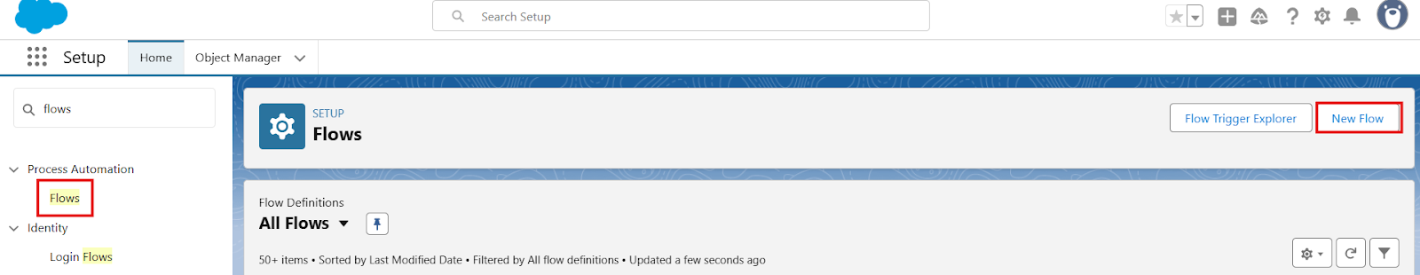
- Select Record-Triggered Flow
- Click Create
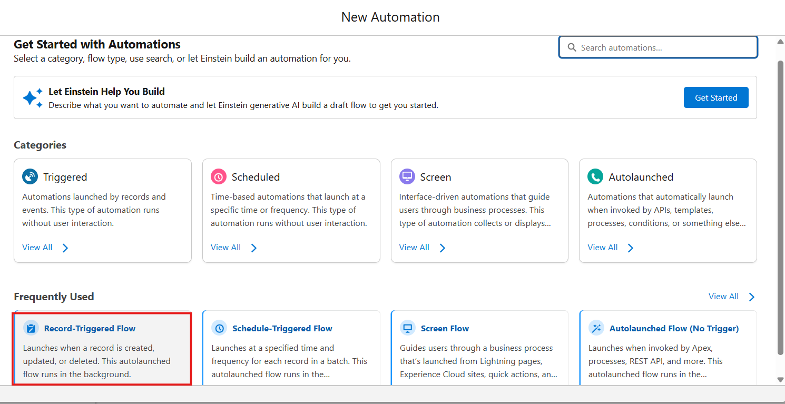

Step 2: Configure the Start (Trigger)
On the Start panel on the right:
- Object: select Delivery_Update__c
- Trigger the Flow When:
  - Select A record is created
- Condition Requirements:
  - Choose: None (Always Run the Flow)
- Optimize the Flow For:
  - Select Actions and Related Records
- Click Done

Part 2: Update Related Shipment Record
Step 3: Add “Update Records” Element
- Click the + icon under the Start element
- Select Update Records
Configure the Update Records Element:
- Label: Update_Shipment_Status
- How to Find Records to Update:
  - Select Specify conditions to identify records
Set Filter Conditions:
- Object: Shipment__c
- Field: Id
- Operator: Equals
- Value: {!$Record.Shipment__c}
(This means update the Shipment linked to the Delivery Update)

Set Field Values to Update
Add field mapping:
Shipment Field | Value Source
Status__c | {!$Record.Status__c}

(This copies status from Delivery Update to Shipment)
- Click Done
Part 3: Save and Activate
Step 4: Save Flow
- Click Save (top-right)
- Flow Label: Auto_Update_Shipment_Status
- API Name will auto-fill
- Click Save
Step 5: Activate Flow
- Click Activate
- Flow status should show Active
Final Flow Layout:
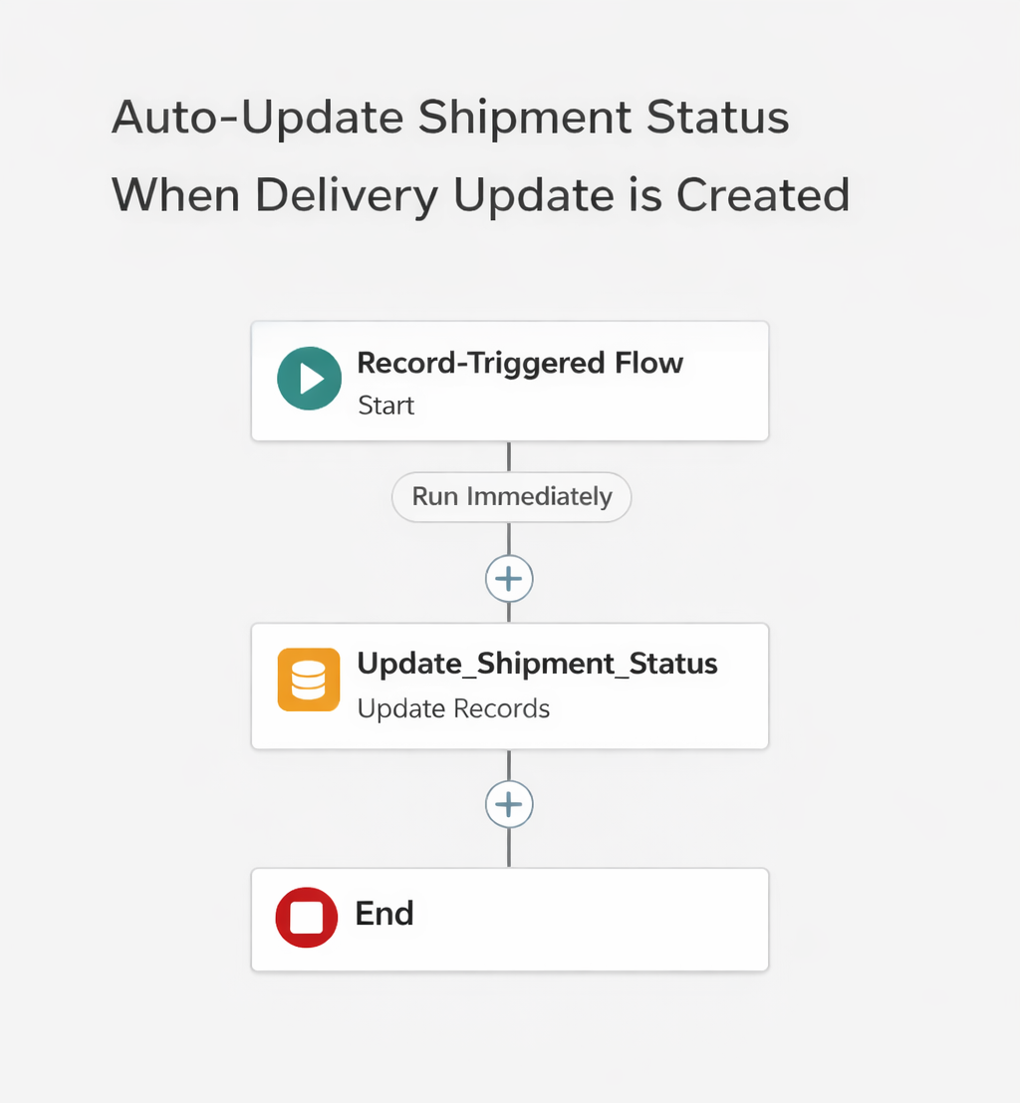

Milestone 8 - The Lightning App :
What is an App ?
Apps in Salesforce are a group of tabs that help the application function by working together
as a unit. It has a name, a logo, and a particular set of tabs. The simplest app usually has just
two tabs.

Activity 1: Create a Lightning App
Create the Courier Management System App
- From Setup, enter App Manager in the Quick Find and select App Manager.
- Click New Lightning App.
  - Enter the Courier Management System as the App Name.
- Upload an image or icon for the app, then click Next.
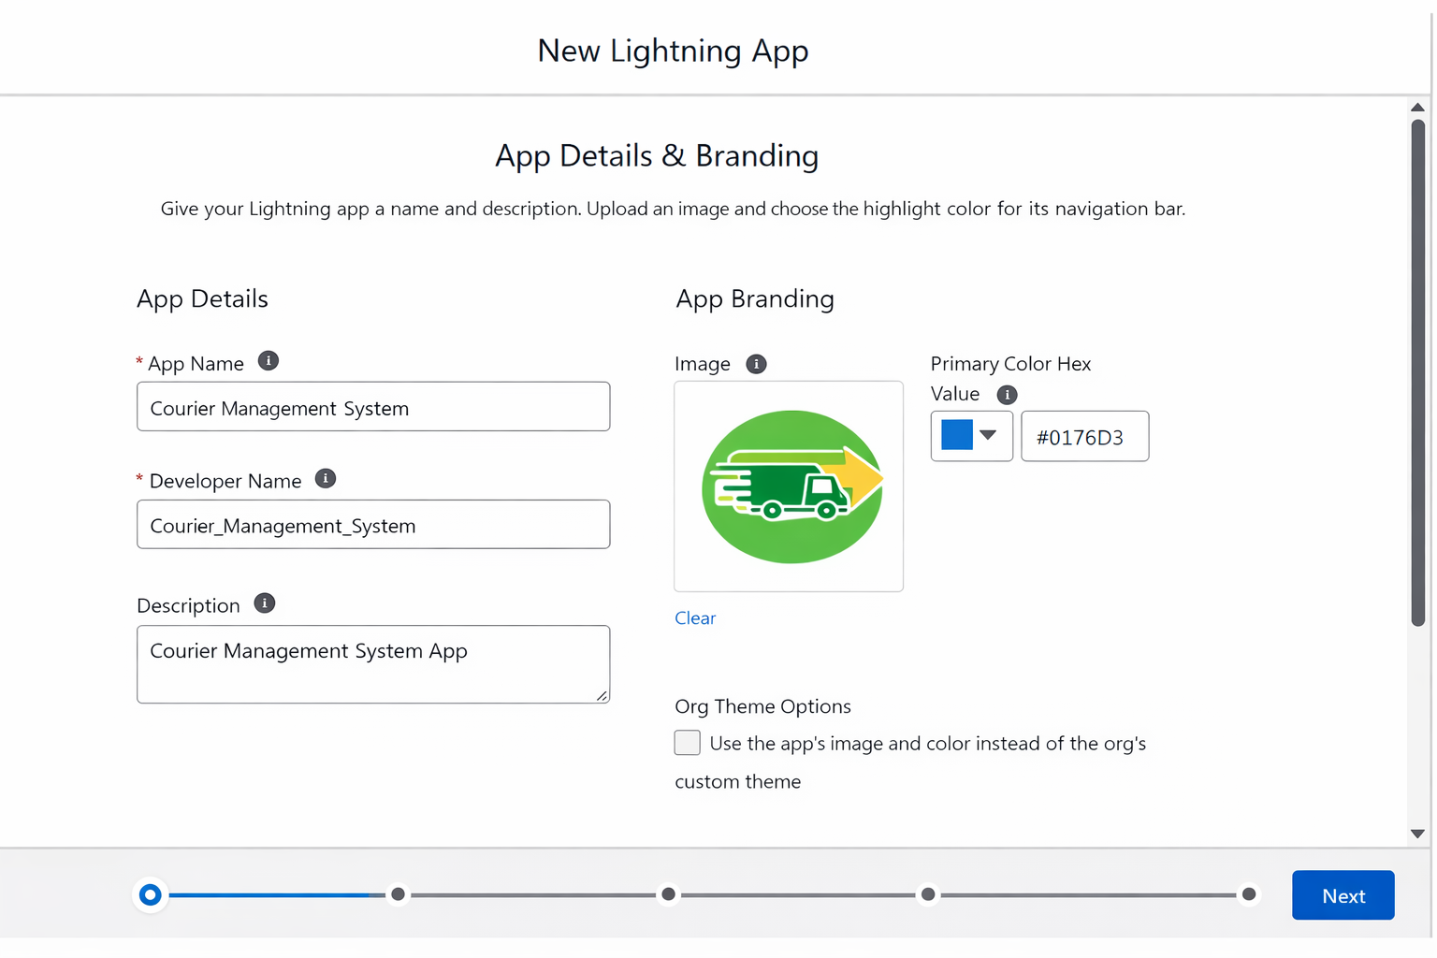
- Under App Options, leave the default selections and click Next.
- Under Utility Items, leave as it is and click Next.
- From Available Items, select the following and move them to Selected Items:
  - Customer
  - Shipment
  - Delivery Agent
  - Branch
  - Delivery Update
  - Invoice
  - Reports
  - Dashboards
- Click Next.
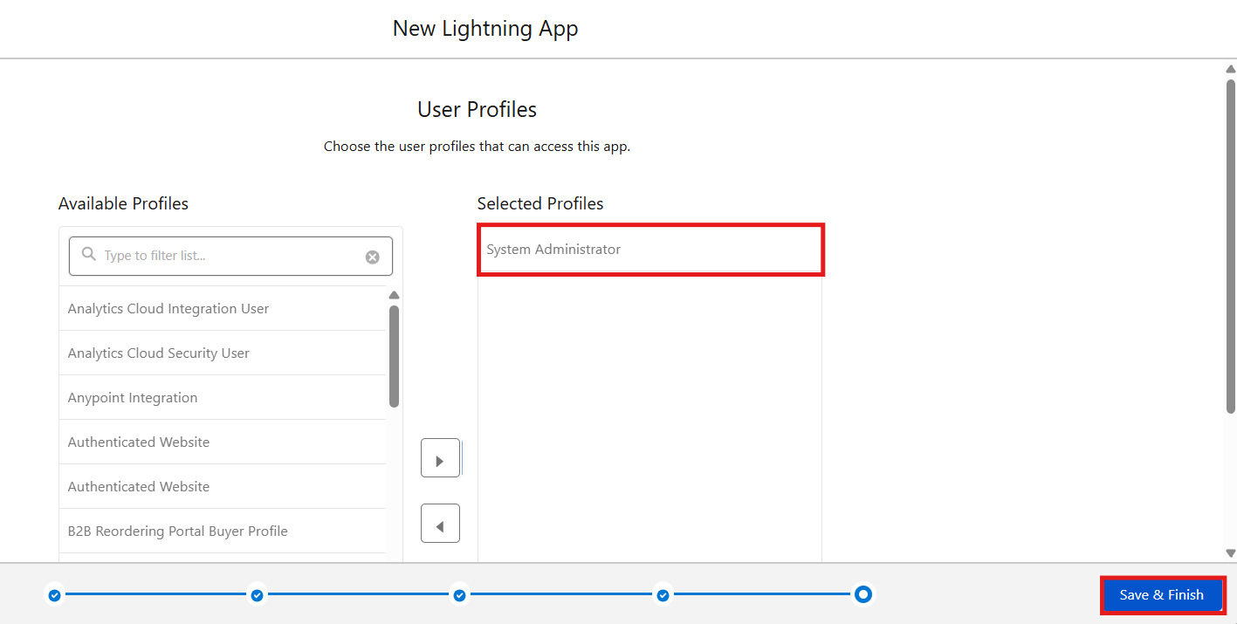
- From Available Profiles, select System Administrator and move it to Selected Profiles.
- Click Save & Finish.

Milestone 9- Profile:
What is a profile?
A profile is a group/collection of settings and permissions that define what a user can do in salesforce. A profile controls “Object permissions, Field permissions, User permissions, Tab
settings, App settings, Apex class access, Visualforce page access, Page layouts, Record Types,
Login hours & Login IP ranges.
A profile can be assigned to many users, but users can be assigned a single profile at a time.

Activity 1: Create a Custom Profile – Courier Admin
Create a Custom Profile:
- From Setup, enter Profiles in the Quick Find box.
- Click Profiles.
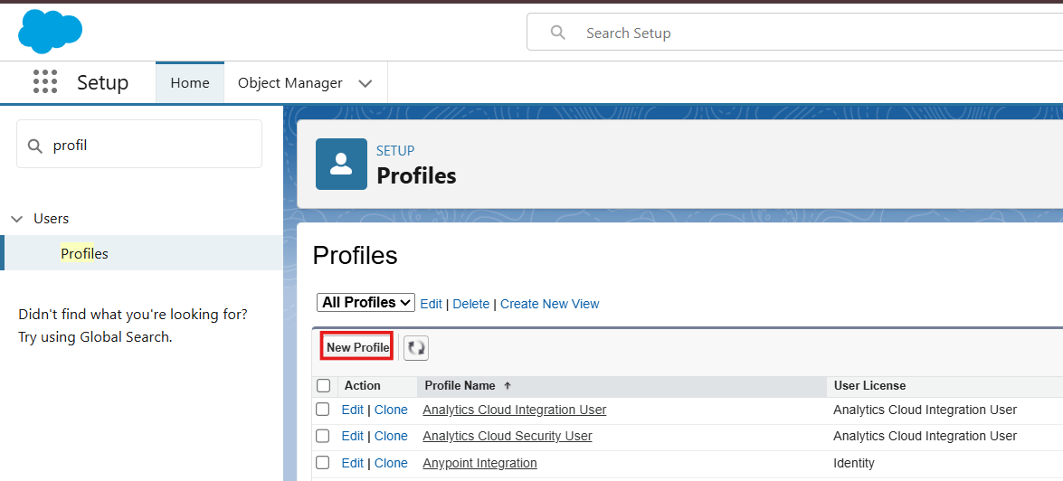
- Click New Profile.
- Select Existing Profile as: System Administrator.
- Enter Profile Name: Courier Admin.
- Click Save.
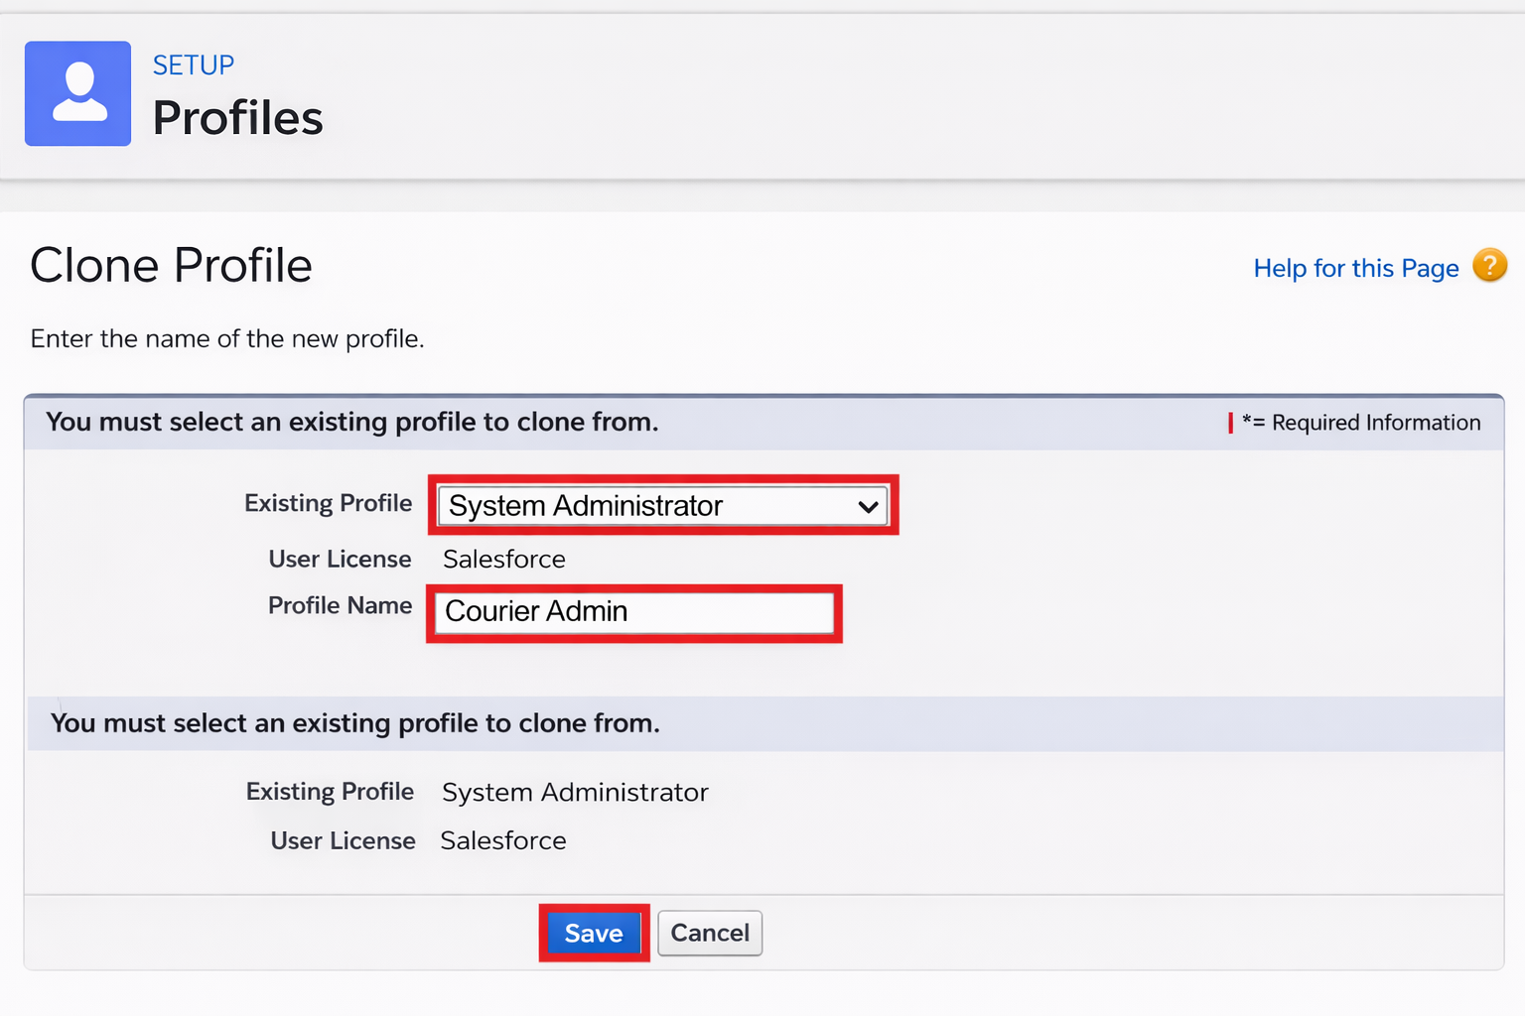
Why use System Administrator as Base?
It already has:
- Modify All Data
- Customize Application
- Full CRUD access on all objects
By cloning it, the Courier Admin profile automatically inherits full access.
You can later restrict permissions if required.

Activity 2: Create a Custom Profile – Branch Manager
Steps:
- From Setup, enter Profiles in the Quick Find box.
- Click Profiles.
- Click New Profile.
- Select Existing Profile as: Standard Platform User.
- Enter Profile Name: Branch Manager.
- Click Save.
- Click Edit on the Branch Manager profile.
Set App & Tab Settings
Under Assigned Apps / Custom App Settings, set the default app to:
Courier Management System App
Ensure Visible Tabs Include:
Set these tabs as Default On or Visible:
- Customers
- Shipments
- Delivery Agents
- Branches
- Delivery Updates
- Invoices
- Reports
- Dashboards
Custom Object Permissions
Scroll to Custom Object Permissions and set access as follows:
Object | Permissions to Grant
Customer__c | Create, Read, Edit
Shipment__c | Create, Read, Edit
Delivery_Agent__c | Read, Edit
Branch__c | Read, Edit
Delivery_Update__c | Create, Read, Edit
Invoice__c | Read
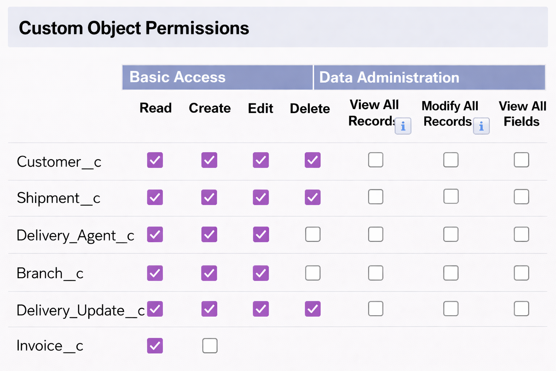

Session & Password Settings
Under Session Settings:
- Session Timeout: 2 Hours of Inactivity
Under Password Policies:
- User passwords expire in: Never Expires
- Minimum Password Length: 8
Click Save.

Activity 3: Create a Custom Profile – Delivery Agent
Steps:
- Setup → Quick Find → Profiles
- Click New Profile
- Existing Profile: Standard Platform User
- Profile Name: Delivery Agent
- Click Save
App & Tab Access
Default App: Courier Management System
Visible Tabs:
- Shipments
- Delivery Updates
Object Permissions :
Object | Permissions
Shipment__c | Read, Edit
Delivery_Update__c | Create, Read, Edit
Customer__c | Read
Invoice__c | Read
Restrictions
- No access to Branch editing
- No delete permissions
- Limited reporting access
Click Save.

Activity 4: Create a Custom Profile – Customer Support
Steps:
- Setup → Profiles → New Profile
- Base Profile: Standard User
- Profile Name: Customer Support
Access Configuration
Tabs Visible:
- Customers
- Shipments
- Delivery Updates

Object Permissions :
Object | Access
Customer__c | Read, Edit
Shipment__c | Read, Edit
Delivery_Update__c | Read
Invoice__c | Read
Session Settings
- Session Timeout: 2 Hours
- Password Length: 8
Click Save
Final Profiles Created in Project :
Profile Name | Purpose
Courier Admin | Full system control
Branch Manager | Manage shipments and agents
Delivery Agent | Update delivery status
Customer Support | Handle customers and tracking

Milestone 10- Role:
In Salesforce, roles are used to determine which users have access to certain data and functions within the system. They are also used to define the reporting hierarchy within an organization. Users with higher roles have greater access to data and more control over the system.

Activity 1: Creation of Courier Admin Role
Creation of Role:
- From the Quick Find box, search for Roles and click on the Roles option.
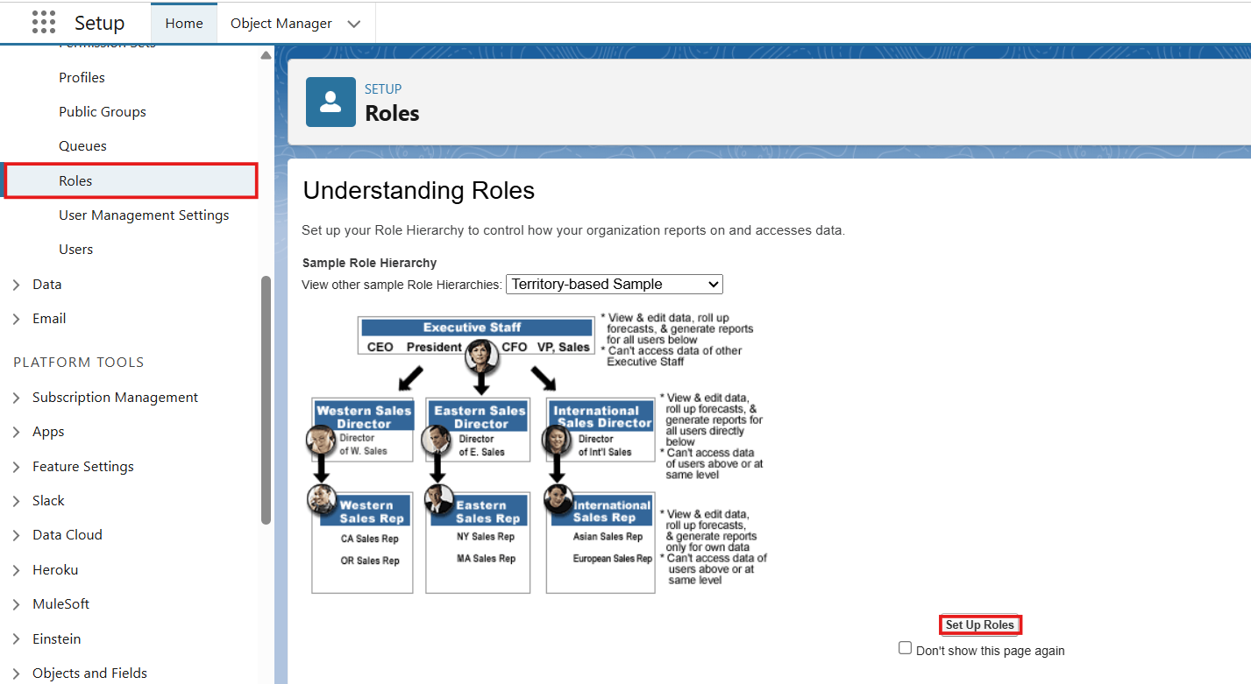
- Select Set Up Roles.
- Click on Expand All and click Add Role under CEO.
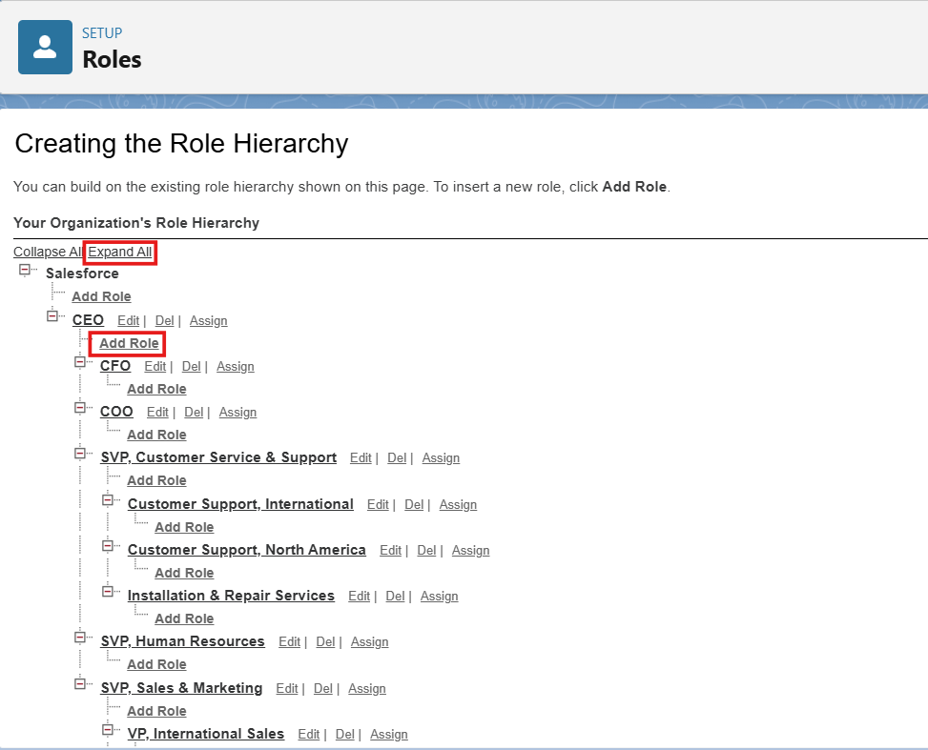
- Give Label as “Courier Admin”.
  - The Role Name will auto-populate.
- Click Save.

Activity 2: Creating Branch Manager Role Under Courier Admin Role
Create another role:
- Create a role with the name “Branch Manager”.
- Below the Courier Admin, click on Add Role.
- Enter the label name as “Branch Manager” and the Role Name will automatically populate.
- Click Save.

Activity 3: Creating Delivery Agent Role Under Branch Manager Role
Steps:
- Below the Branch Manager role, click on Add Role.
- Enter Label as “Delivery Agent”.
  - Role Name will auto-populate.
- Click Save.

Activity 4: Creating Customer Support Role Under Branch Manager
Steps:
- Under the Branch Manager role, click on Add Role.
- Enter Label as “Customer Support”.
- Role Name will automatically populate.
- Click Save.
Purpose of This Hierarchy :
- Courier Admin – Highest level access to all data
- Branch Manager – Manages branch-level operations
- Delivery Agent – Access only to assigned shipments
- Customer Support – Limited access to customer and shipment tracking
This hierarchy ensures proper data sharing and security in the Courier Management System.

Milestone 11- User :

What is a user?

A user is anyone who logs in to Salesforce. Users are employees at your company, such as sales,reps, managers, and IT specialists, who need access to the company's records. Every user in Salesforce has a user account. The user account identifies the user, and the user account settings determine what features and records the user can access.

NOTE- As Salesforce license can only be used by 2 Users at a time in Dev Org, So If you don’t find a salesforce license then deactivate a user who has a salesforce license Or change the license type from Salesforce to any other.

Activity 1: To Create a User
Steps:
- From Setup, enter Users in the Quick Find box, then select Users.
- Click New User.
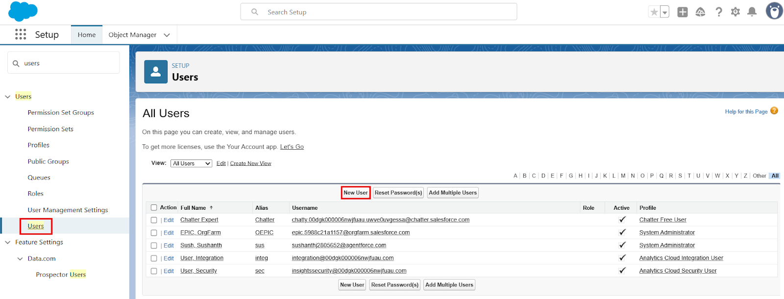
Fill in the Fields:

Field Name | Value
First Name | Enter first name (Example: Ravi)
Last Name | Enter last name (Example: Kumar)
Alias | Give an alias name
Email ID | Enter your personal email ID
Username | Must be in the format: text@text.text and must be unique
Nickname | Give a nickname
Role | Select Courier Admin
User License | Salesforce
Profile | Courier Admin

3. Click Save.

Activity 2: Creating Other Users
Repeat the same steps as Activity 1 for creating additional users.
Use the following details:
User Type | Role | User License | Profile
Branch Manager | Branch Manager | Salesforce | Branch Manager
Delivery Agent | Delivery Agent | Salesforce Platform | Delivery Agent
Customer Support | Customer Support | Salesforce Platform | Customer Support

Example:
To create a Branch Manager User:
- Go to Setup → Users → New User
- Fill details like:

Field | Example Value
First Name | Arjun
Last Name | Reddy
Email | arjun@gmail.com
Username | arjun.manager@cms.com
Role | Branch Manager
Profile | Branch Manager

- Click Save
\
To Create Delivery Agent User:
Follow same steps with:
- Role: Delivery Agent
- Profile: Delivery Agent
To Create Customer Support User:
- Role: Customer Support
- Profile: Customer Support
Important Points
- Every user must have:
  - Unique username
  - Valid email
  - Assigned Role
  - Assigned Profile
- Profiles control permissions
- Roles control data visibility

Milestone 15 : Reports & Dashboards
Reports and Dashboards help analyze business data and track courier operations efficiently.

Activity 1: Create Report Types
Step 1: Open Report Types
- Click Gear Icon → Select Setup.
- In Quick Find search Report Types.
- Click New Custom Report Type.
Step 2: Create Shipment Report Type
- Primary Object: Shipment__c
- Label: Shipment Tracking Report
- Category: Reports
- Deployment Status: Deployed
- Click Next → Save
Step 3: Create Customer Report Type
- Primary Object: Customer__c
- Label: Customer Summary Report
- Category: Reports
- Deployment Status: Deployed
- Click Next → Save
Step 4: Create Agent Performance Report Type
- Primary Object: Delivery_Agent__c
- Label: Agent Performance Report
- Category: Reports
- Deployment Status: Deployed
- Click Next → Save

Activity 2: Create Reports
Report 1: Shipment Status Summary Report
Step 1: Create the Report
- Click App Launcher (9 dots) → Search Reports
- Click New Report
- Choose Shipment Tracking Report
- Click Continue
Step 2: Add Columns
Add these fields:
- Tracking Number
- Customer
- Status
- Expected Date
- Assigned Agent
Step 3: Add Filters
- Show Me: All Shipments
- Date Filter: This Month
- Status Filter: Select specific Status (Optional)
Step 4: Group & Summarize
- Group rows by Status__c
- Add summary on Price
Step 5: Save Report
- Click Save & Run
- Name: Shipment Status Summary
- Folder: CMS Reports

Report 2: Agent Performance Report
Step 1: Create Report
- New Report → Choose Agent Performance Report
- Click Continue
Step 2: Add Columns
- Agent Name
- Branch
- Number of Shipments
- Status
Step 3: Group Data
- Group by Delivery_Agent__c
Step 4: Save Report
- Name: Agent Performance Report
- Folder: CMS Reports
- Save & Run
Report 3: Revenue Report
Steps
- Create report using Shipment Tracking Report Type
Add fields:
- Tracking Number
- Customer
- Price
- Invoice Status
Group by:
- Branch
- Month
Save as: Revenue by Branch Report

Activity 3: Create Dashboard
Step 1: Open Dashboards
- Click App Launcher (9 dots)
- Search Dashboards
- Click New Dashboard
Step 2: Enter Dashboard Details
- Name: Courier Management Dashboard
- Folder: CMS Reports
- Click Create

Activity 4: Add Dashboard Components
Component 1: Shipment Status Overview (Donut Chart)
- Click + Component
- Choose report: Shipment Status Summary
- Visual Type: Donut Chart
- Click Add
Component 2: Agent Performance (Bar Chart)
- Select report: Agent Performance Report
- Chart Type: Bar Chart
- Click Add

Component 3: Revenue by Branch (Column Chart)
- Choose report: Revenue by Branch Report
- Chart Type: Column Chart
- Click Add

Activity 5: Save & Activate Dashboard
- Click Save
- Click Done
Share Dashboard With:
- Courier Admin
- Branch Managers
- Customer Support Team

Final Layout :
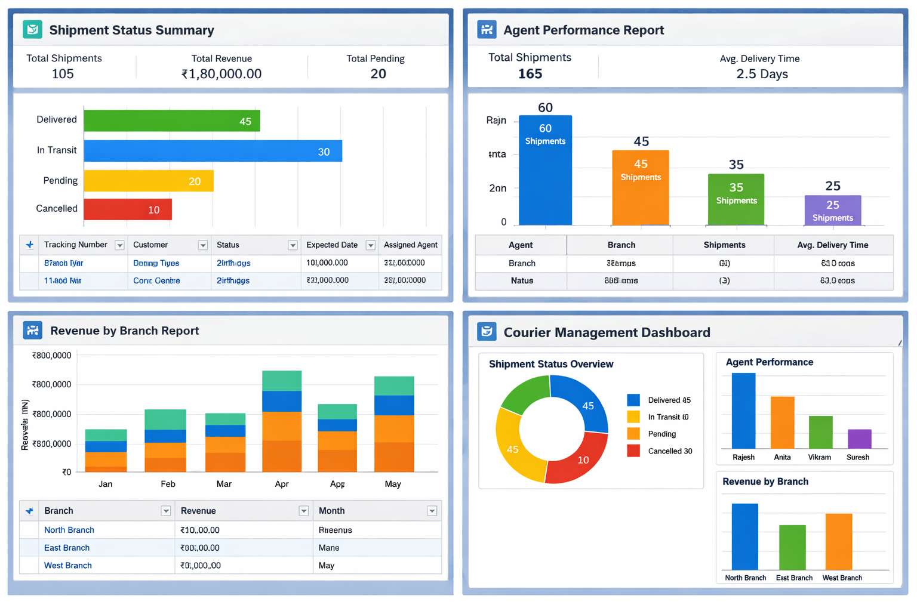

7. FUNCTIONAL & PERFORMANCE TESTING

During testing, screenshots were captured from Salesforce to verify record creation, validation rule enforcement, delivery status updates, flow automation, invoice generation, and dashboard visualization. All scenarios were validated to ensure correct performance and reliability.

8. ADVANTAGES & DISADVANTAGES

Advantages
- Centralized data
- Automated workflows
- Real-time reporting

Disadvantages
- Salesforce dependency
- Requires initial configuration effort

9. Conclusion:

The Courier Management System successfully digitizes courier operations using Salesforce automation, improving efficiency, accuracy, and customer satisfaction.

10. FUTURE SCOPE
- Mobile tracking app
- GPS integration
- SMS notifications
- AI-based delivery optimization

11. APPENDIX
- Source Code: Salesforce Configuration
- Dataset: Salesforce Objects
- GitHub / Demo: Salesforce Developer Org

Thank You

